PMSCS 623P Quiz – 2 Spring, 2026

- A company requires reliable internet and phone connectivity between its five offices, labeled A, B, C, D, E and F, located in New York. The phone company offers dedicated communication links between certain pairs of offices. Each link has an associated annual cost (in thousands of dollars), as shown in the given graph. Among all possible ways to connect the offices, find the configuration with the minimum total annual cost.  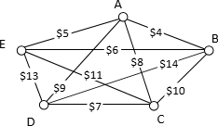 | 5
2. Apply BFS algorithm on the above graph starting from node C. | 5

PMSCS 623P Quiz – 2 Spring, 2026

- A company requires reliable internet and phone connectivity between its five offices, labeled A, B, C, D, E and F, located in New York. The phone company offers dedicated communication links between certain pairs of offices. Each link has an associated annual cost (in thousands of dollars), as shown in the given graph. Among all possible ways to connect the offices, find the configuration with the minimum total annual cost.  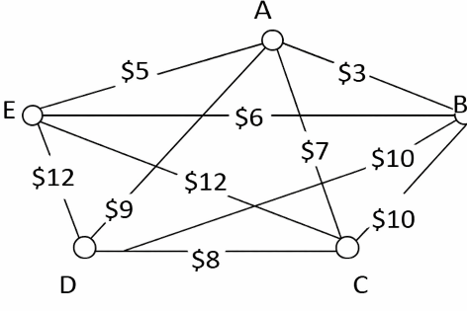 | 5
2. Apply BFS algorithm on the above graph starting from node B. | 5

PMSCS 623P Quiz – 2 Spring, 2026

- A company requires reliable internet and phone connectivity between its five offices, labeled A, B, C, D, E and F, located in New York. The phone company offers dedicated communication links between certain pairs of offices. Each link has an associated annual cost (in thousands of dollars), as shown in the given graph. Among all possible ways to connect the offices, find the configuration with the minimum total annual cost.  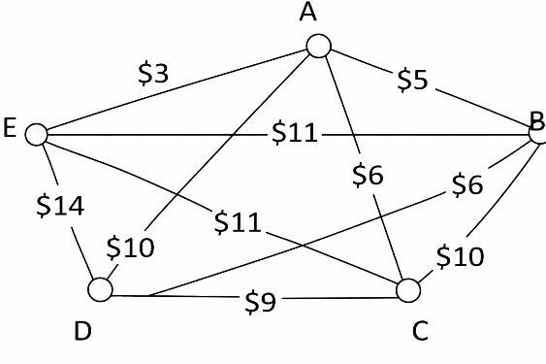 | 5
2. Apply BFS algorithm on the above graph starting from node E. | 5

